ASSIGNMENT – 20
Name-BandiSreesaicharan
Batch-03
2403a54088
-----------------------------------------------------------------------------------------------------------
Task 1: Detect Hardcoded Credentials
PROMPT:
Generate a Python script that connects to a database and includes hardcoded credentials. Then show a secure version that loads the username and password from environment variables using os.getenv().
CODE and OUTPUT:
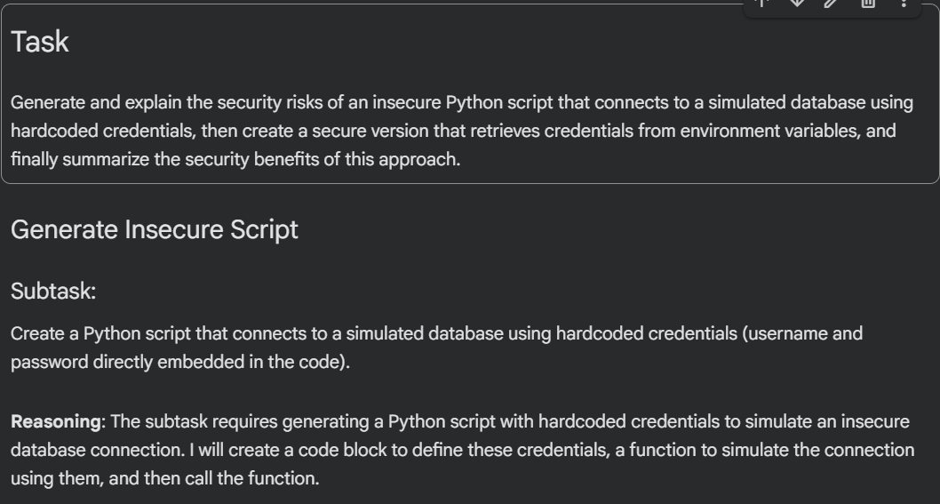
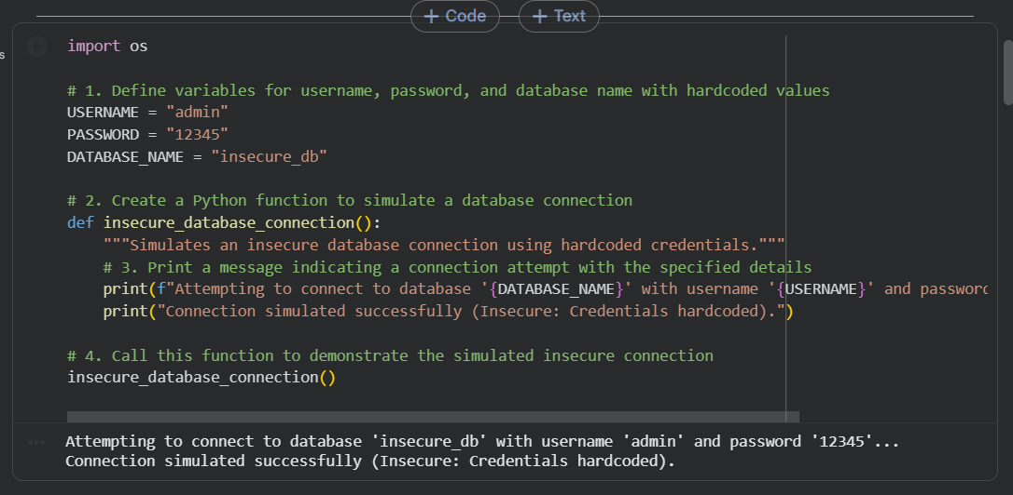
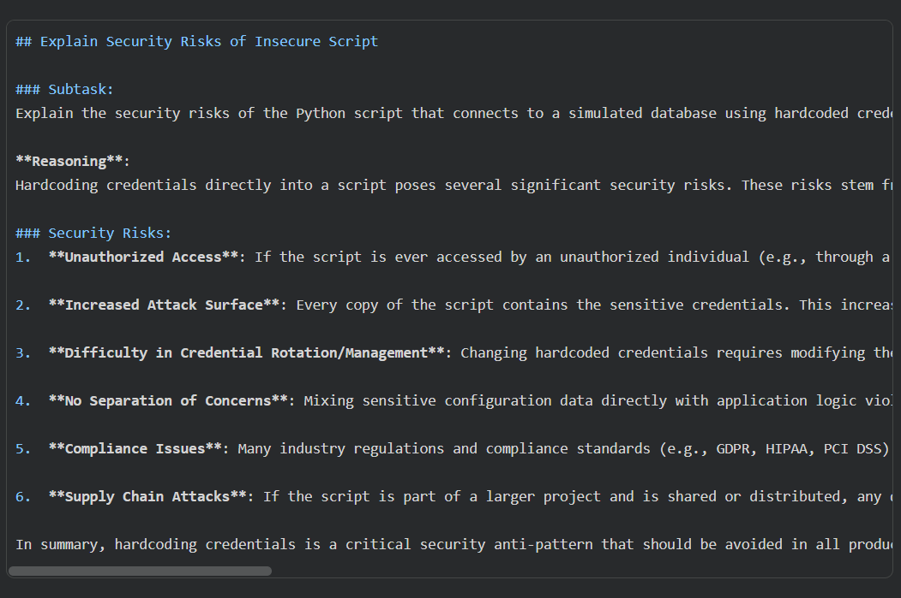
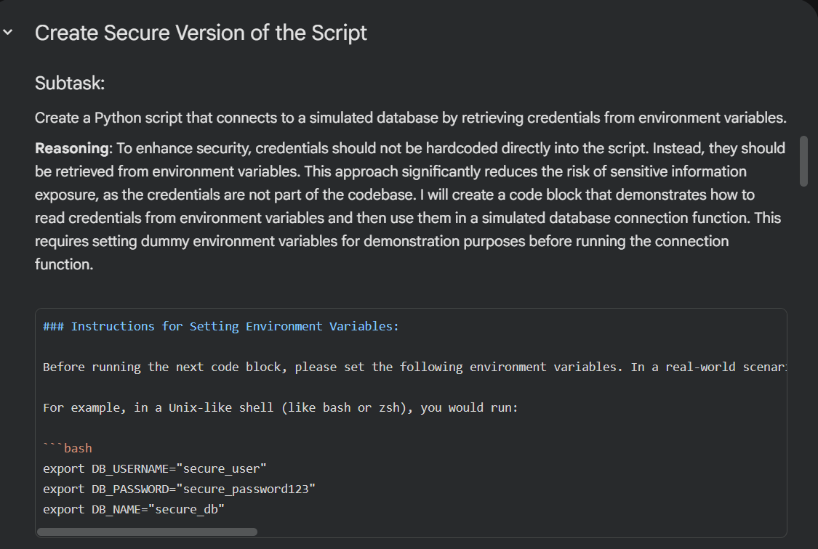
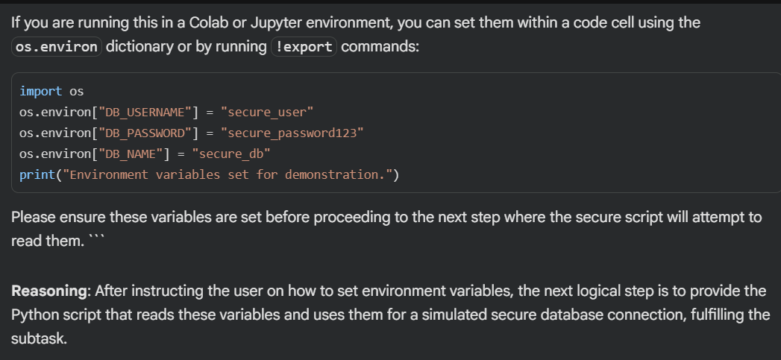
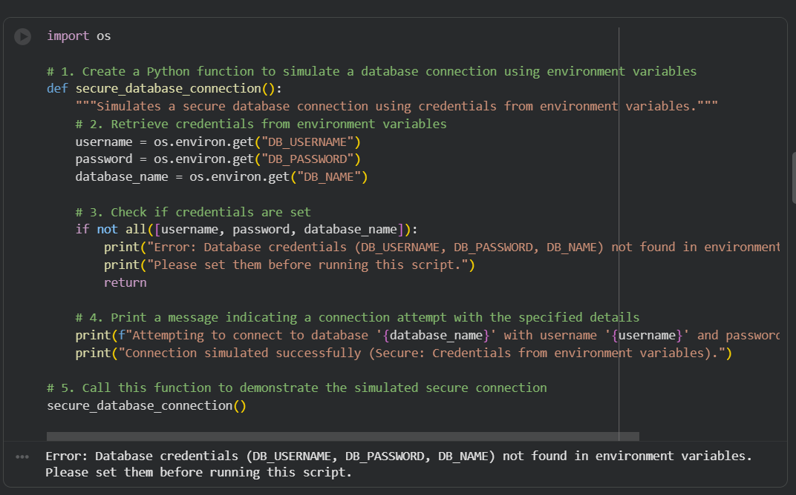
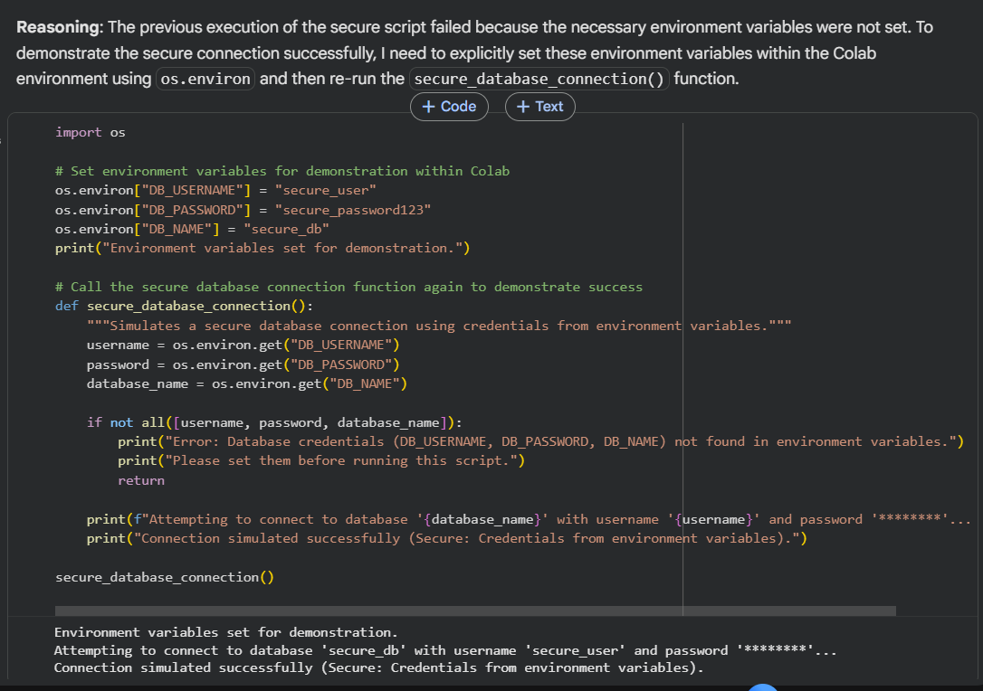
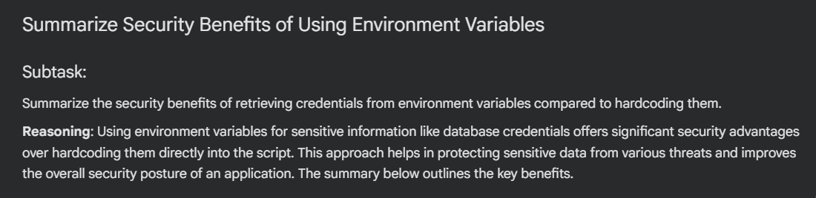
Task 2: Identify SQL Injection Vulnerabilities
Prompt:
Generate a simple Python login using SQLite that contains a SQL-injection vulnerability.
Show a test using the input ' OR '1'='1 and the vulnerable SQL it produces.
Then rewrite the code to use parameterized queries (e.g., cursor.execute(..., (user, pwd))) to prevent SQL injection.
CODE AND OUTPUT:
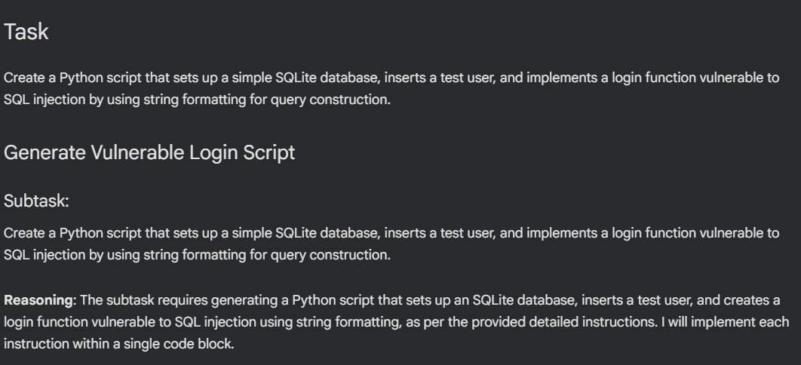
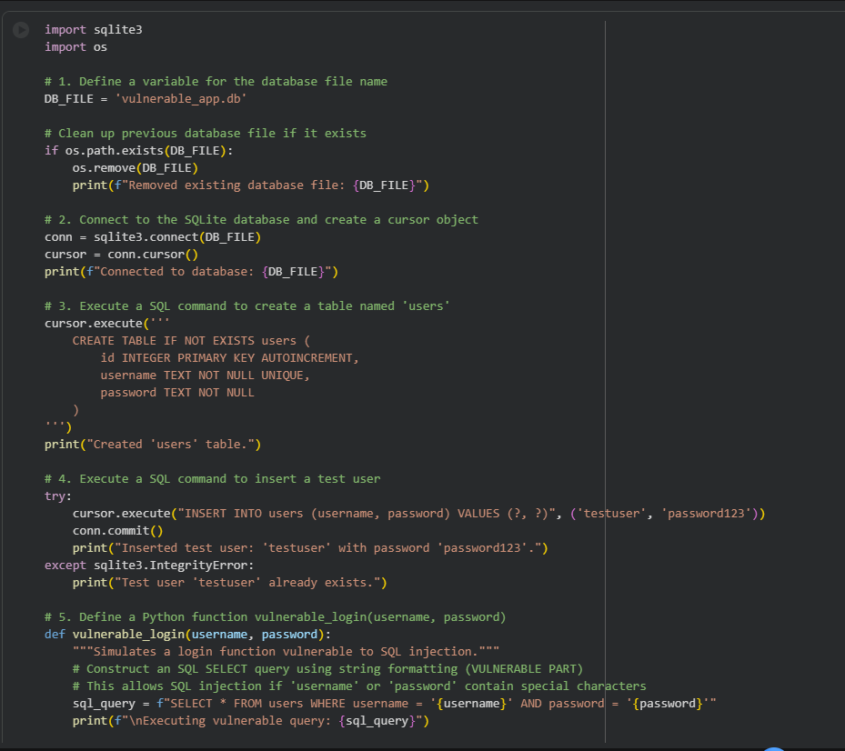
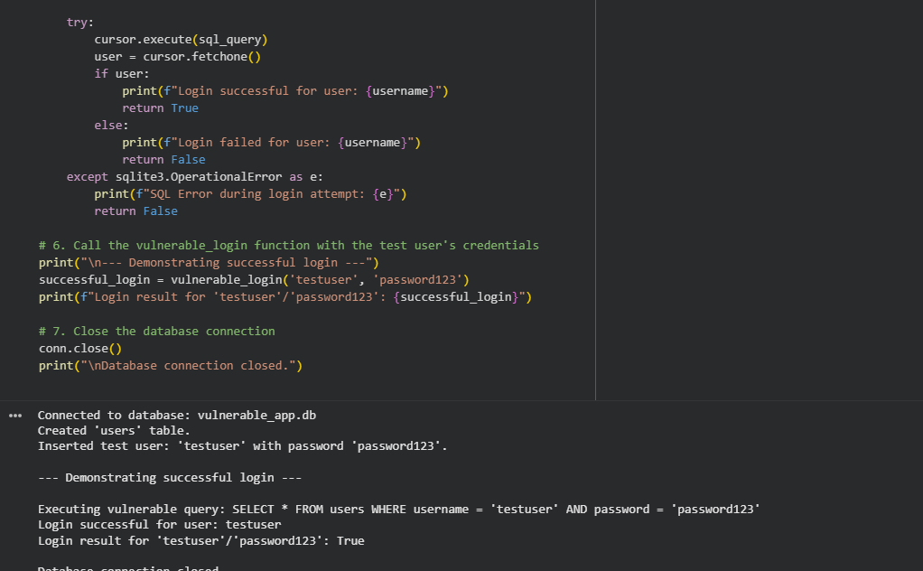
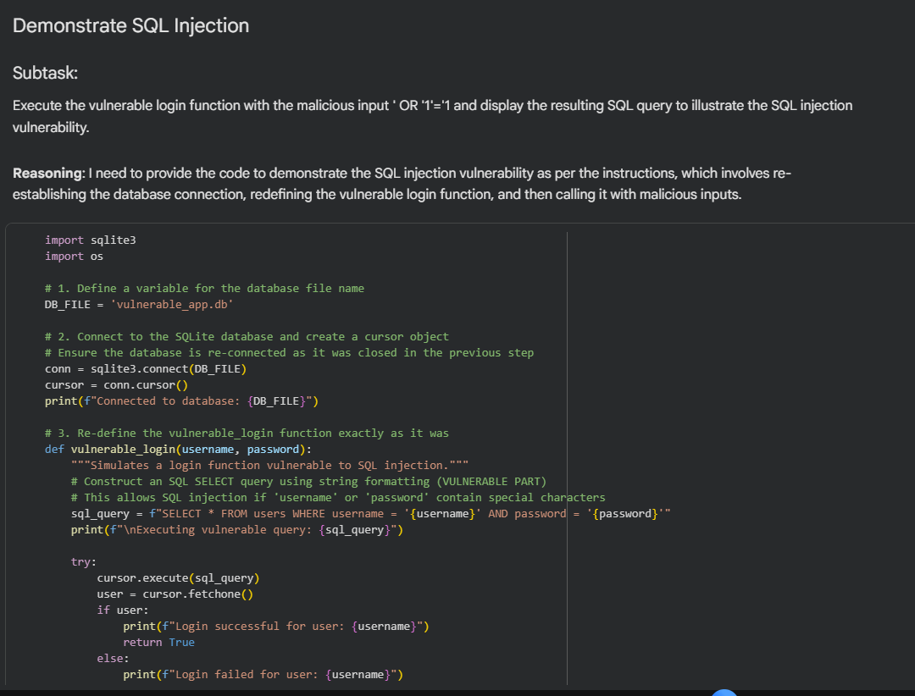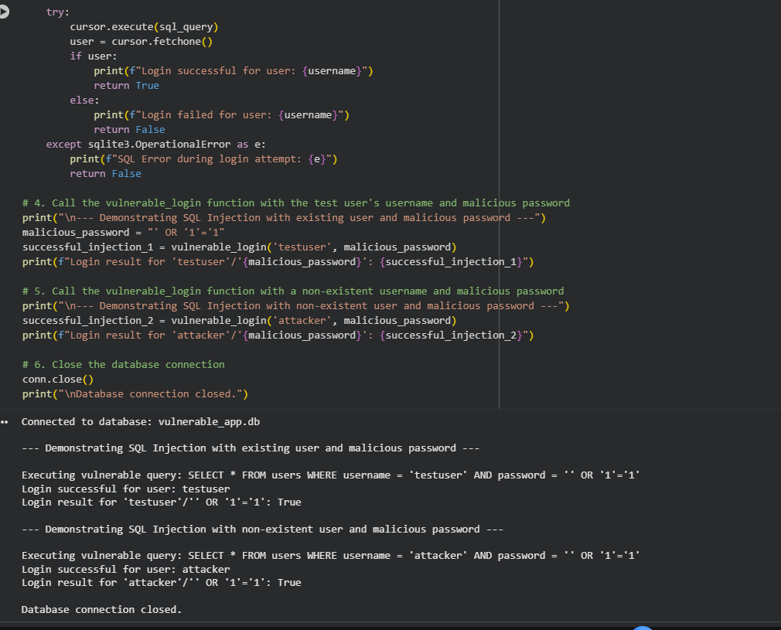

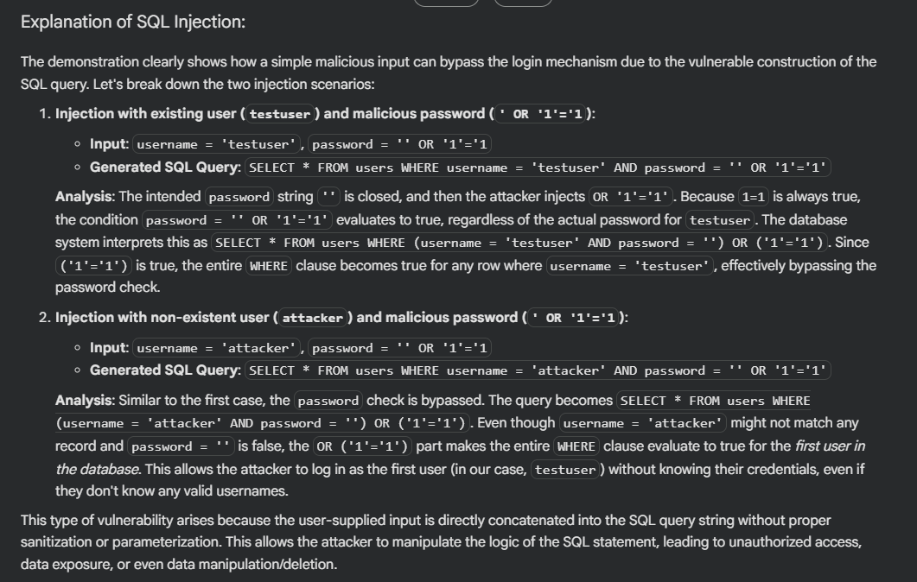
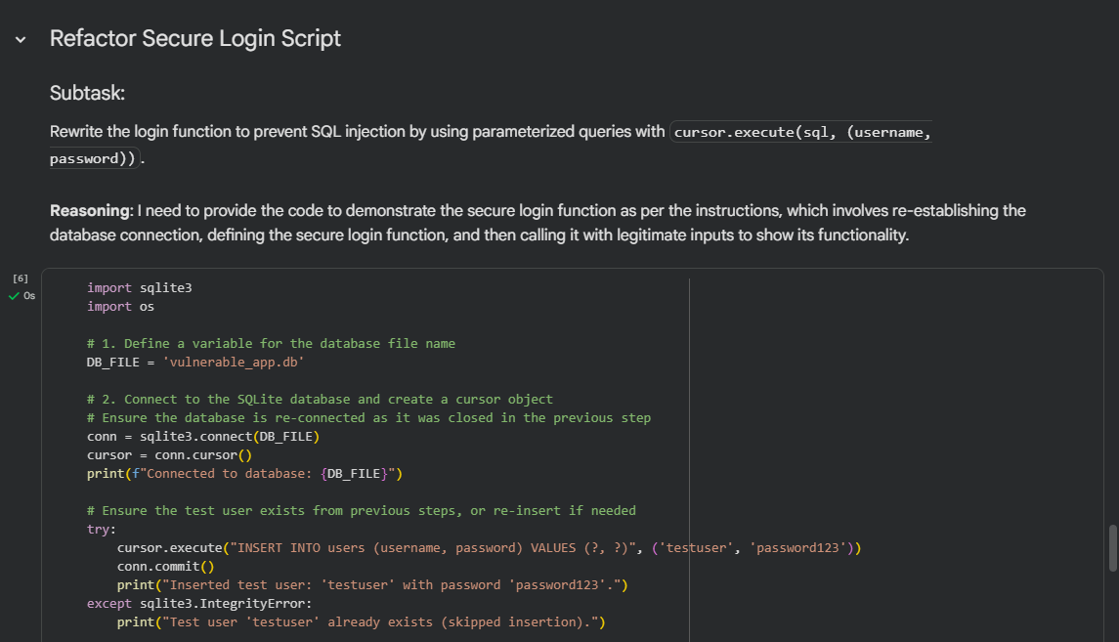
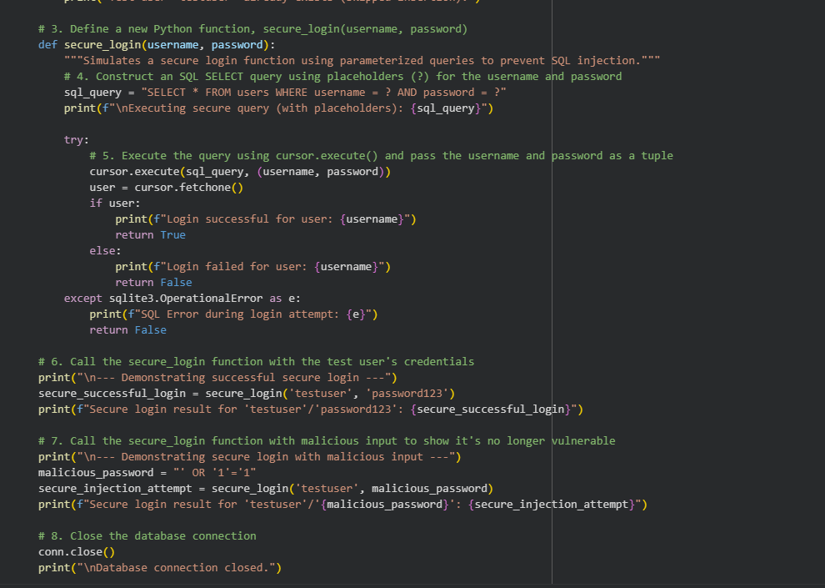
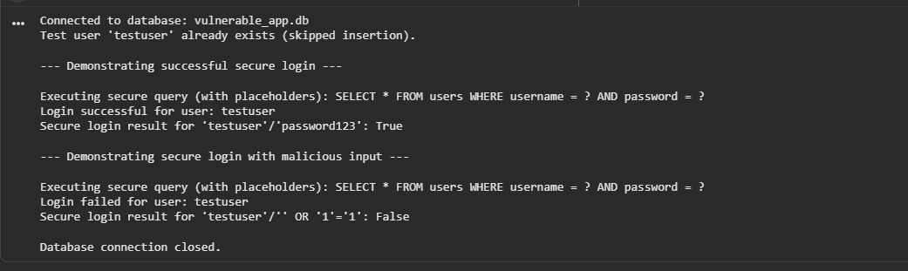
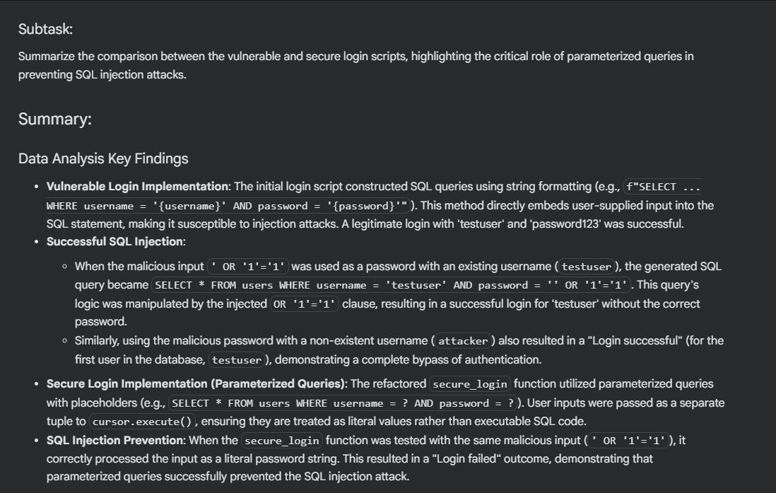

Task 3: Detect Unsafe File Handling
PROMPT:
Generate a Python script that reads a filename from user input and opens it (insecure version that allows path traversal like ../../etc/passwd).
Then provide a secure version that only allows files inside a data/ folder (validate/sanitize the path or normalize and check the final path).

CODE AND OUTPUT:
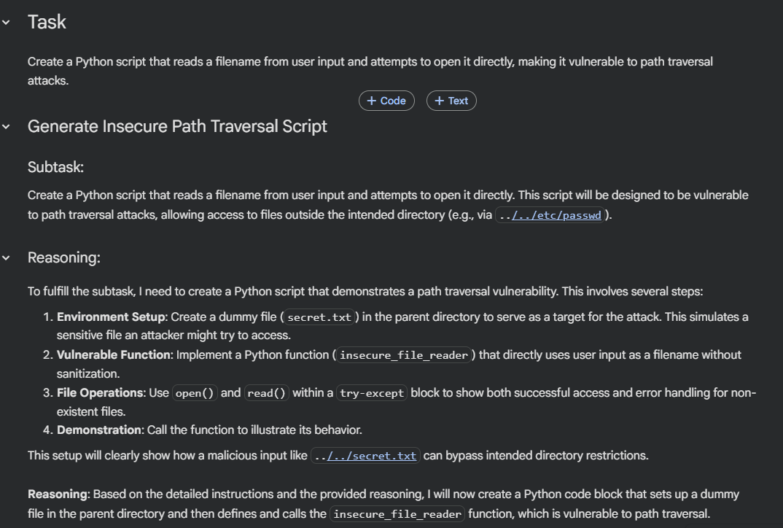
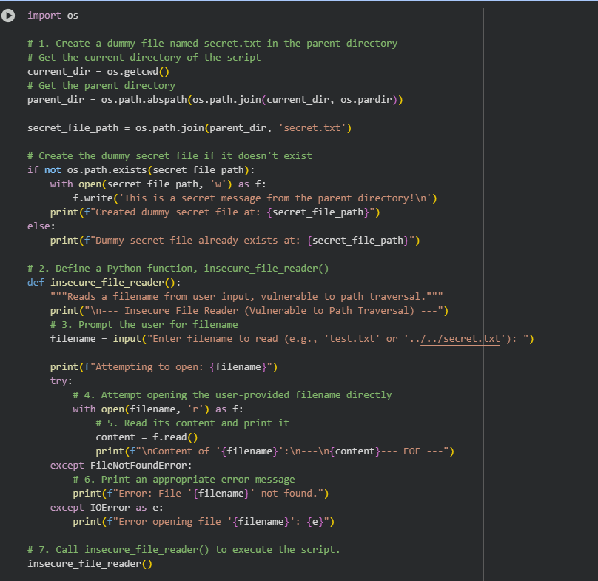
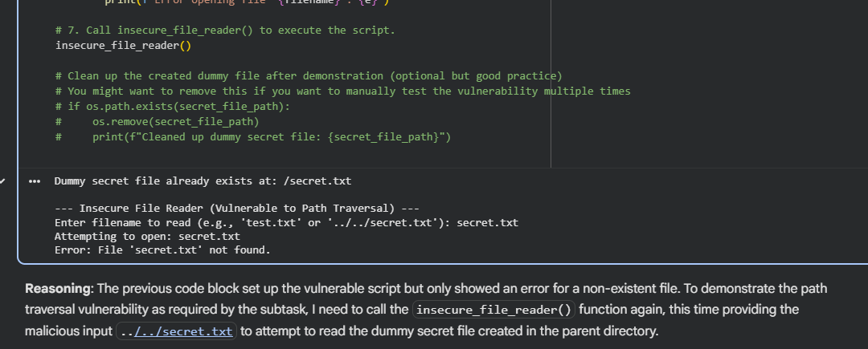
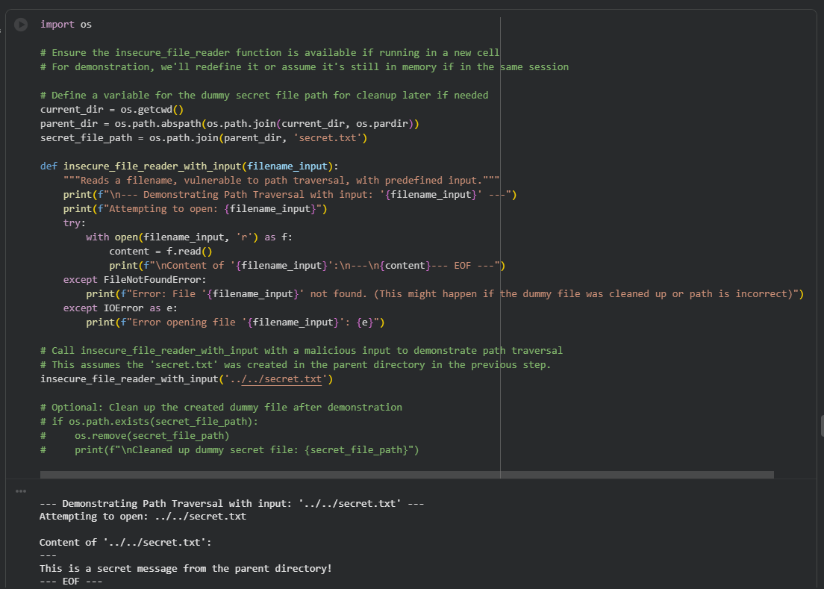

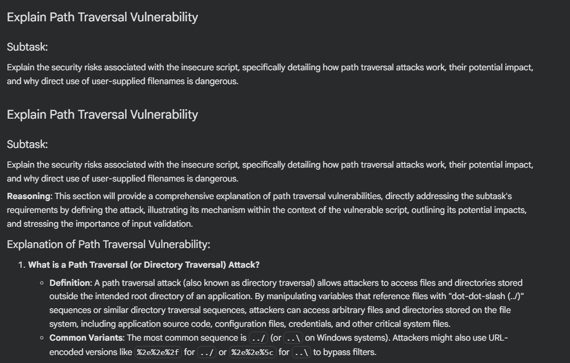
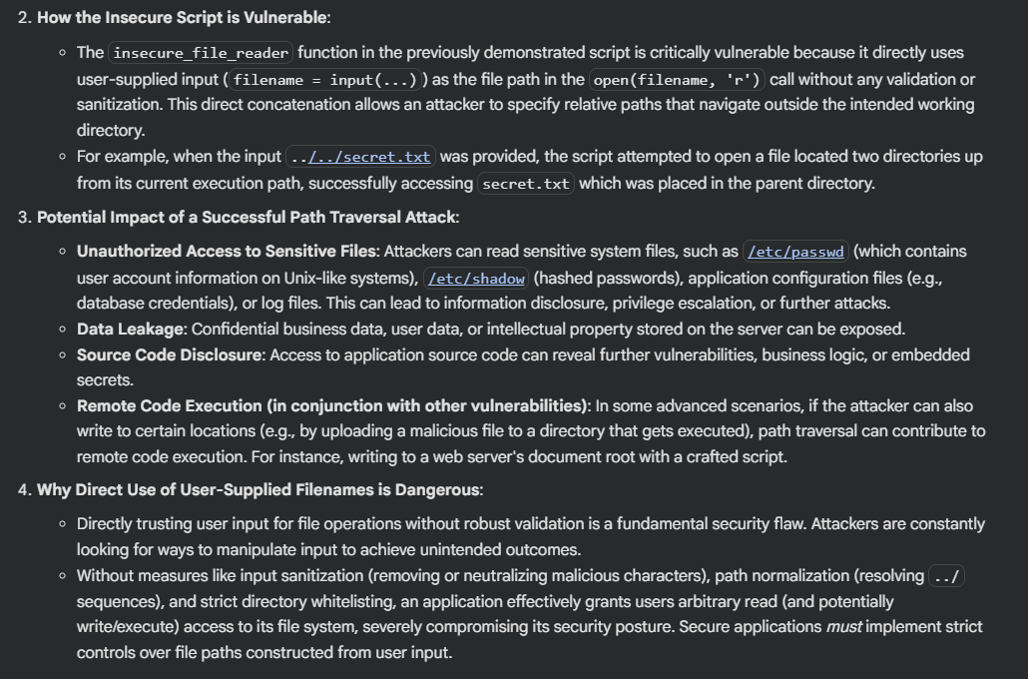
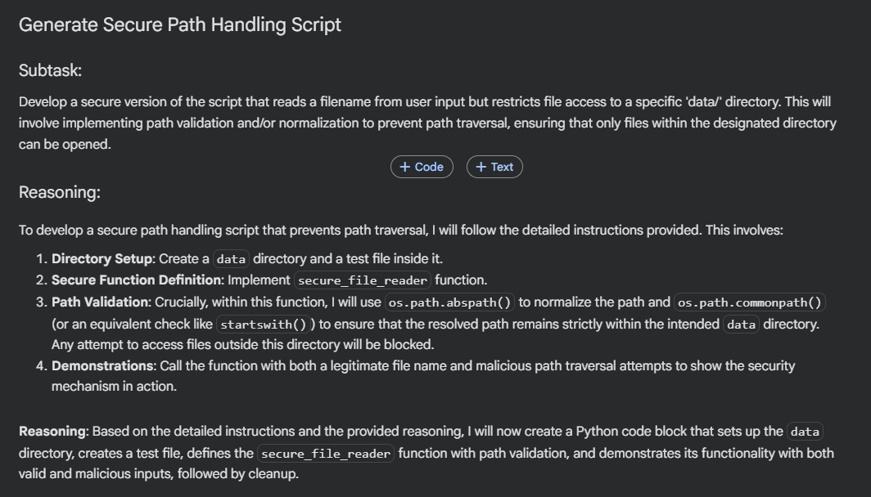
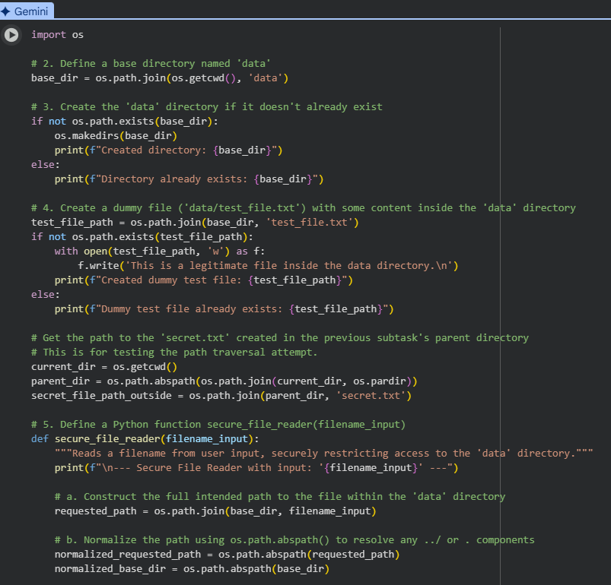
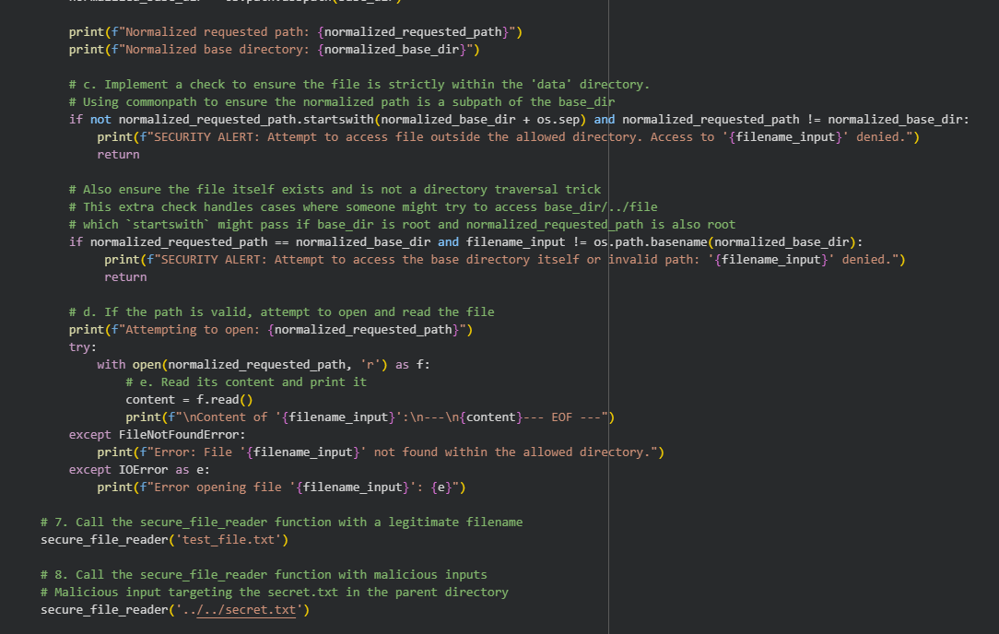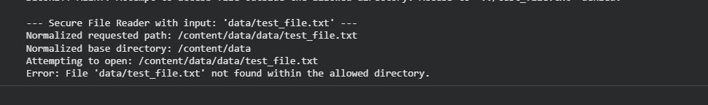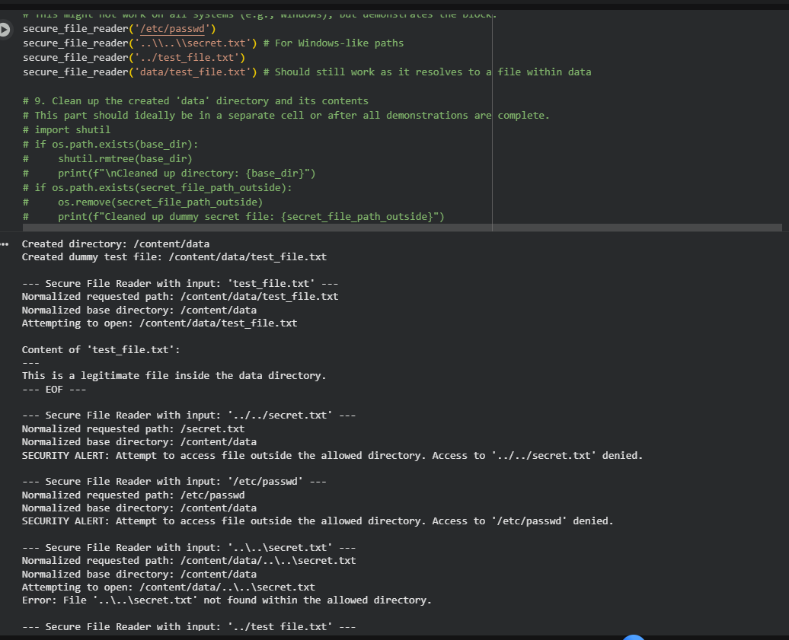

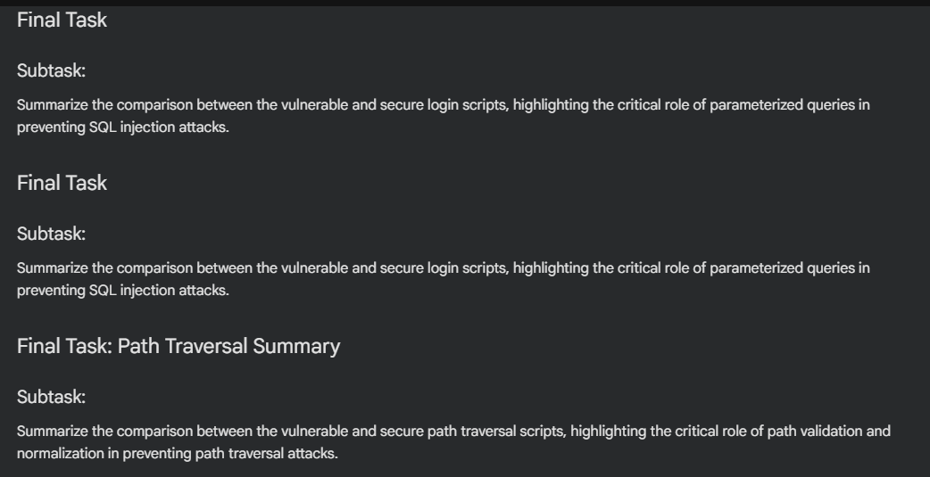
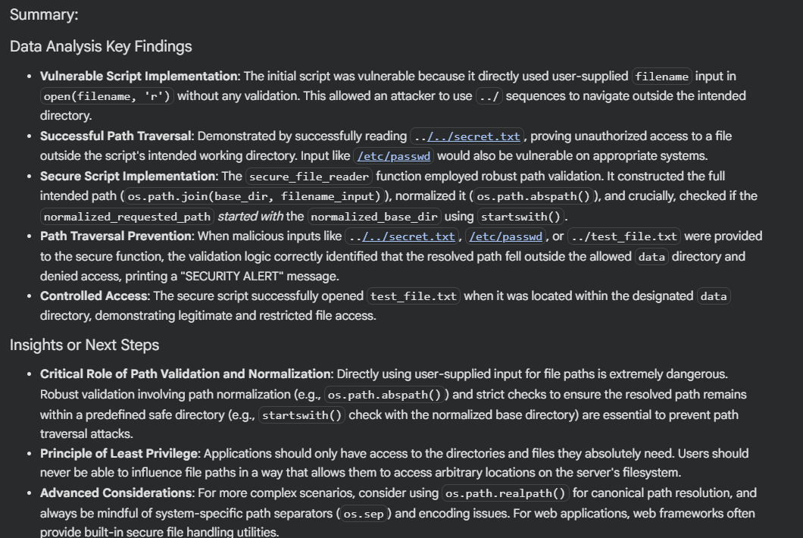
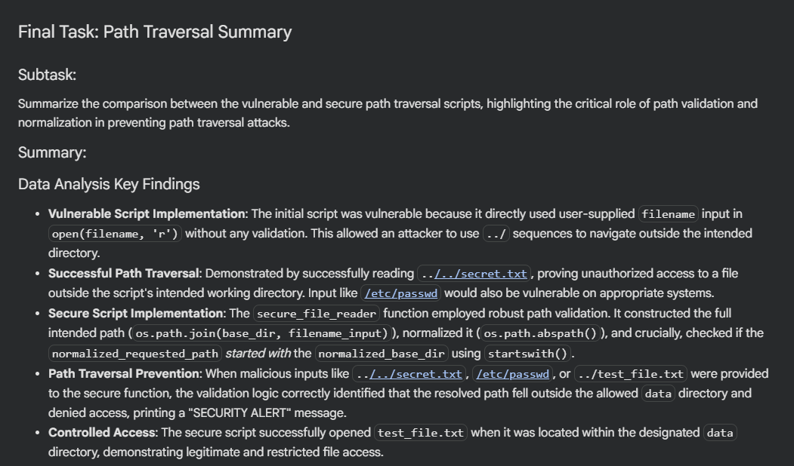

Task 4: Identify Insecure Use of eval() or exec()
PROMPT:
Generate a simple Python calculator that evaluates user input and intentionally uses eval() (vulnerable version).
Show a test with malicious input like __import__('os').system('rm -rf /') to demonstrate the risk.
Then provide a secure version that replaces eval()/exec() with ast.literal_eval() (or a safe parser) and explain in one line why it’s safer.
CODE AND OUTPUT:
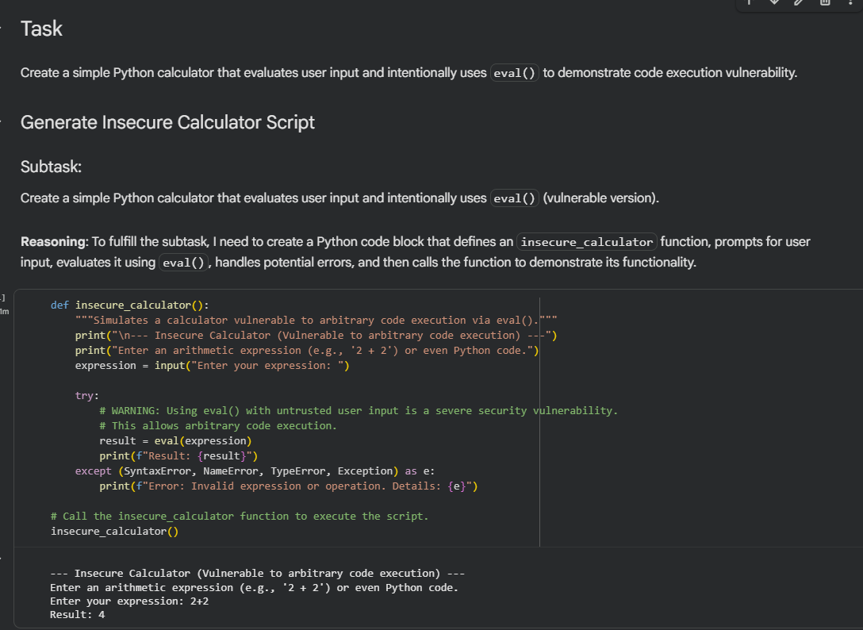
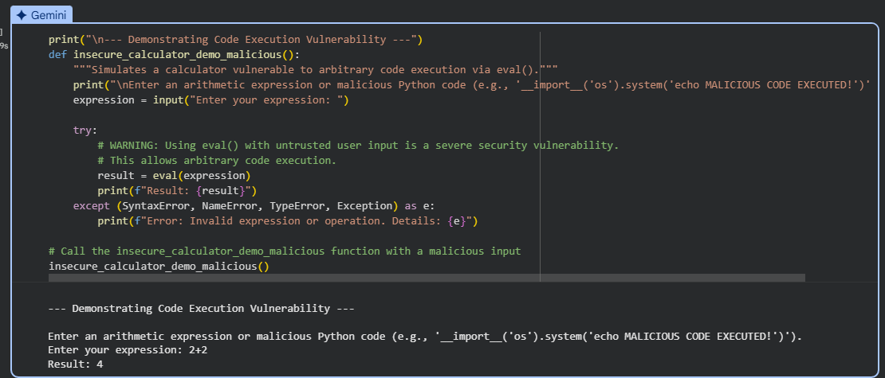
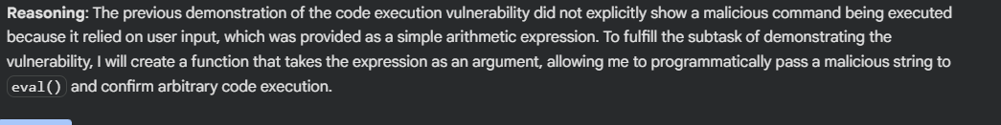
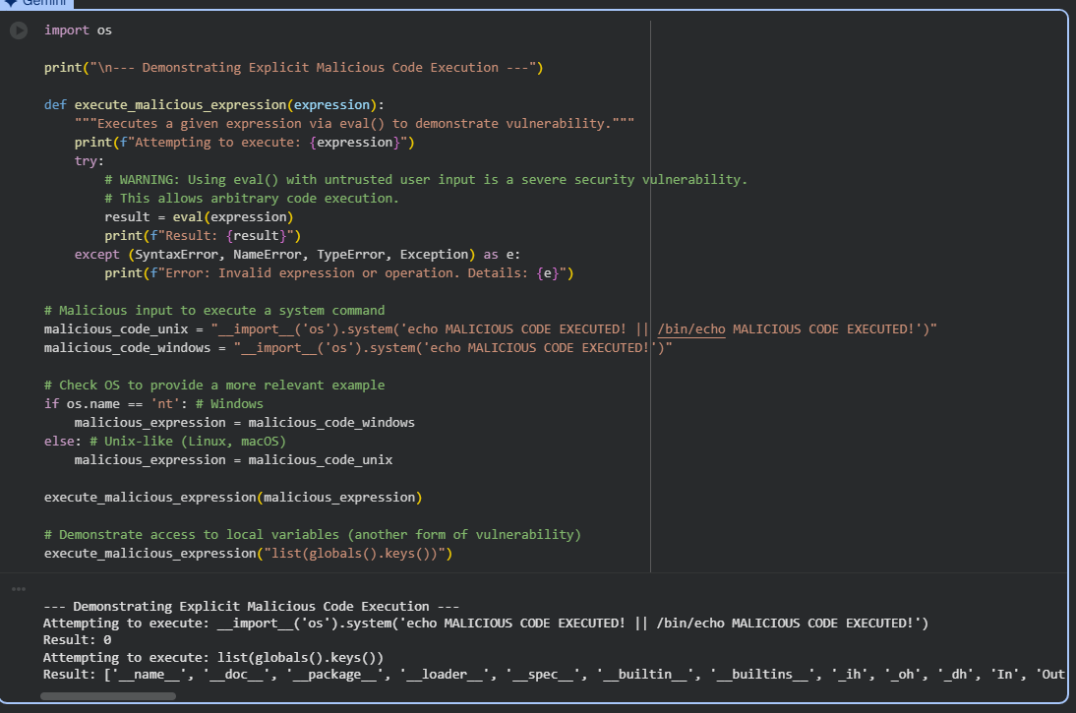
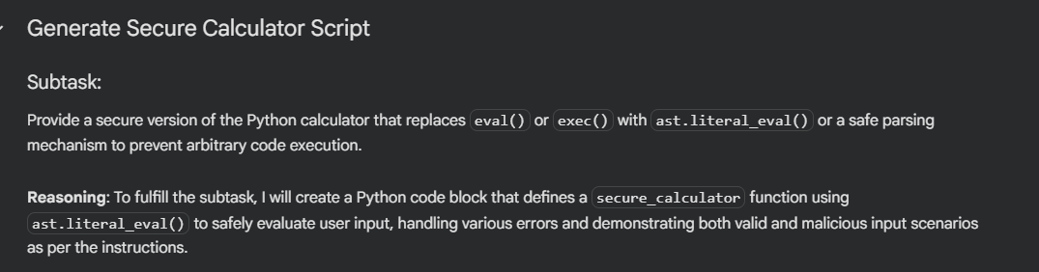
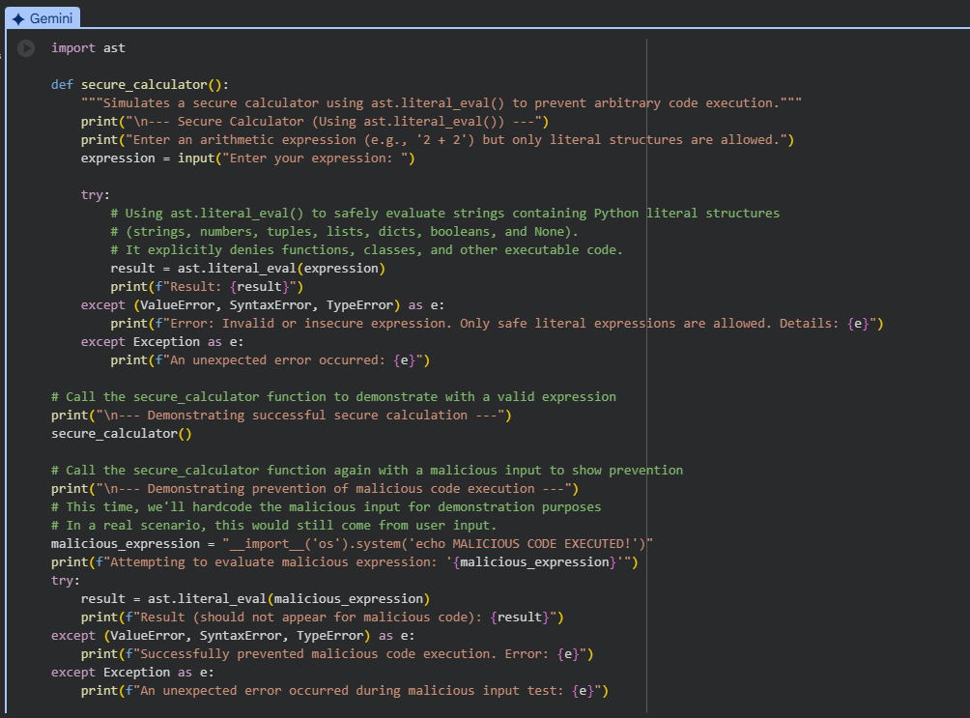
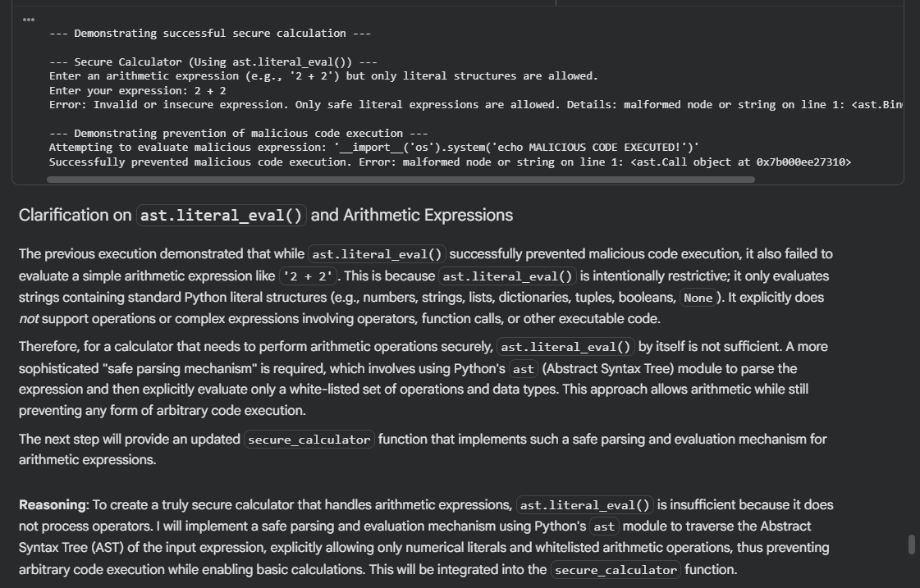

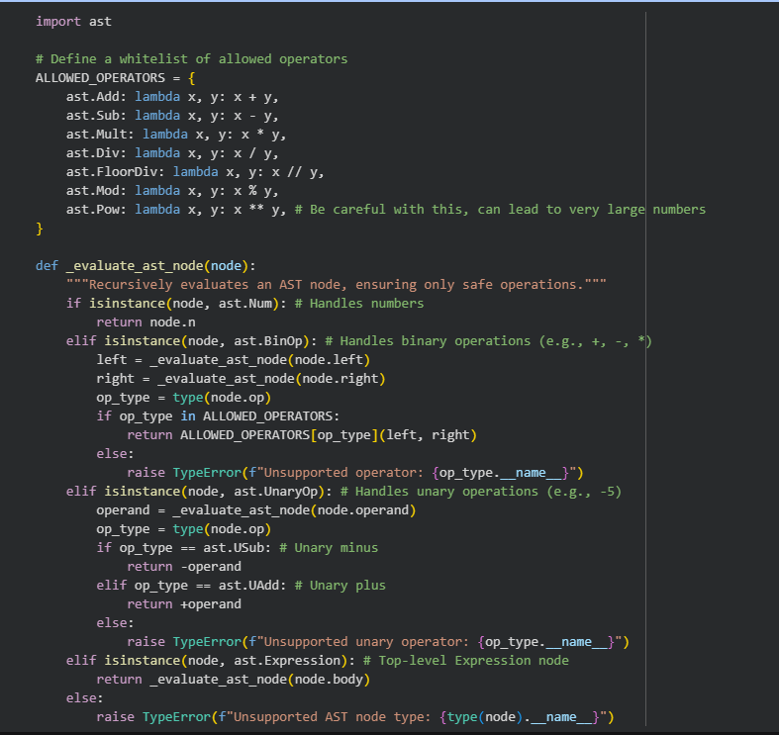
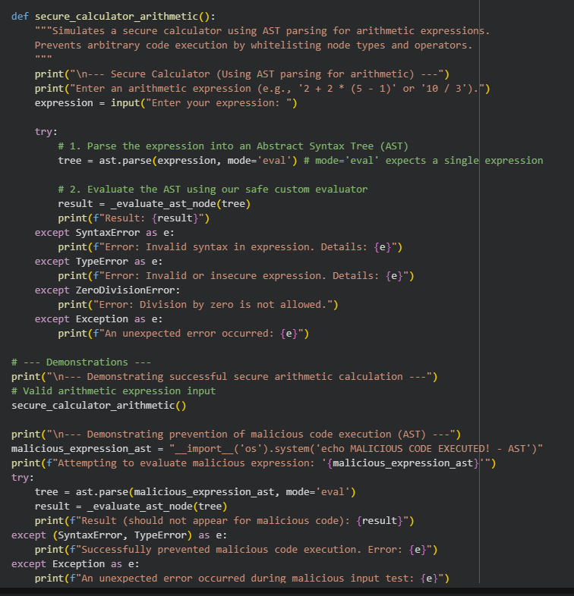

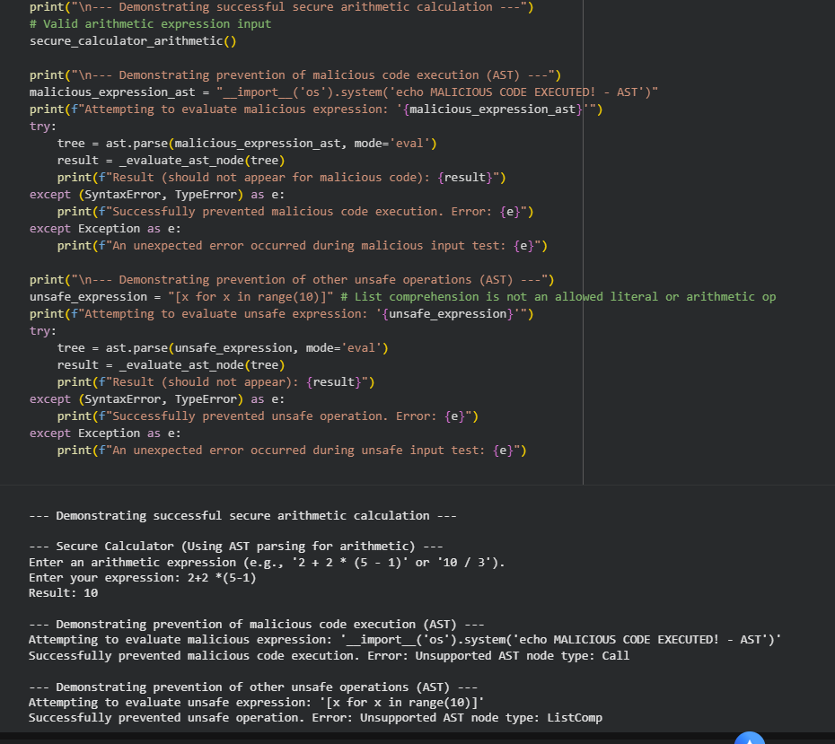

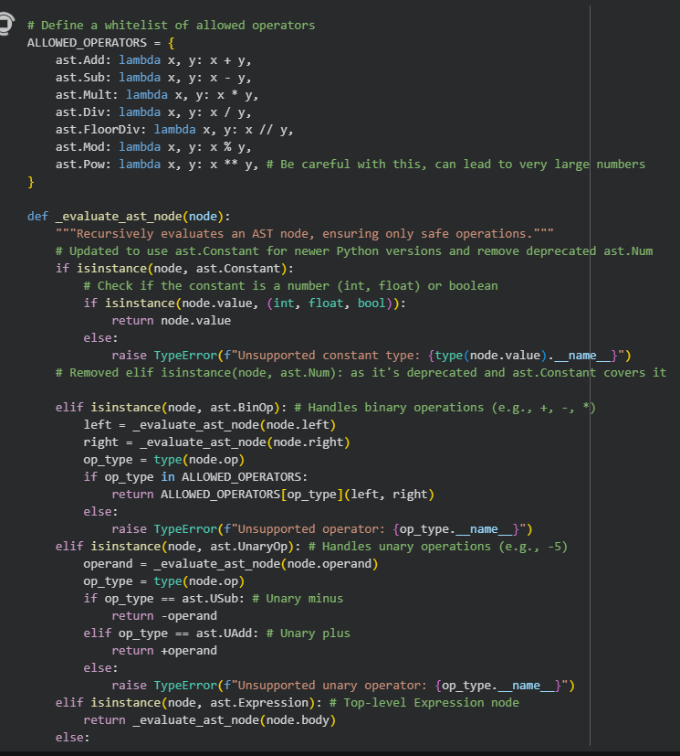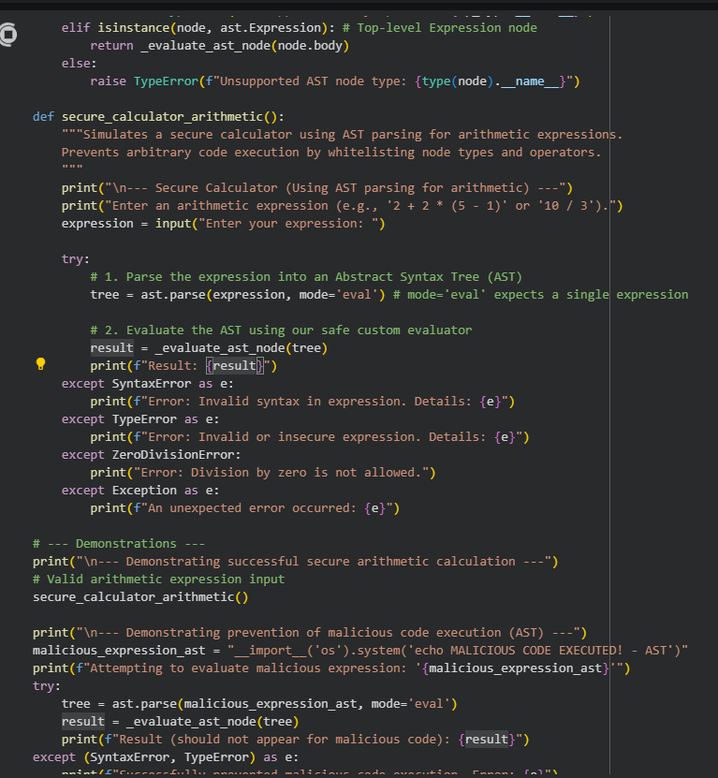
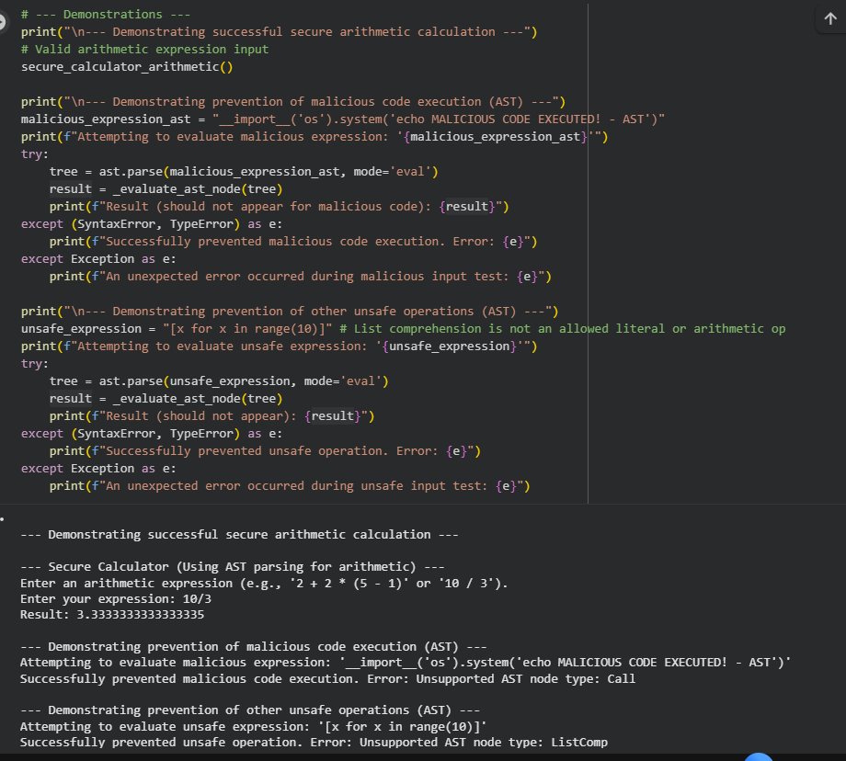
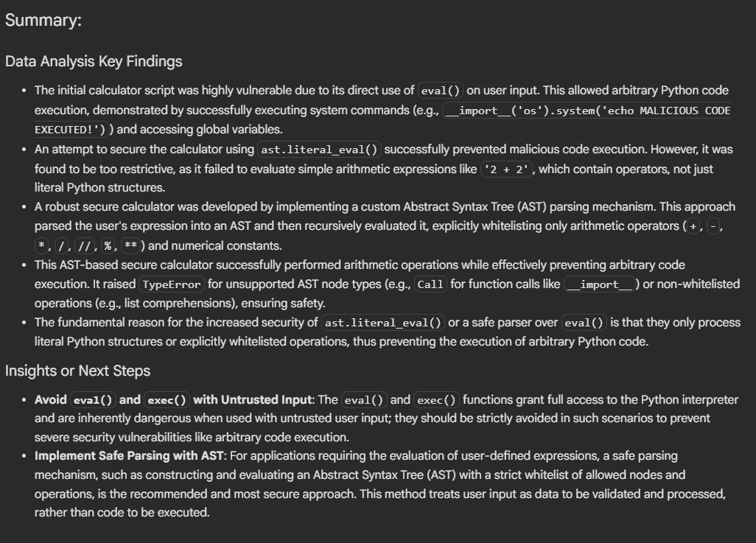

Task 5: Static Security Testing with Linting Tools
PROMPT:
Generate a short Flask web server with at least two security issues (e.g., hardcoded SECRET_KEY, insecure file handling, use of eval/subprocess, or weak crypto).
Output the vulnerable code, run bandit and paste the scan results showing the flagged issues, then provide a fixed version of the code and re-run bandit showing no issues.

CODE and OUTPUT:
